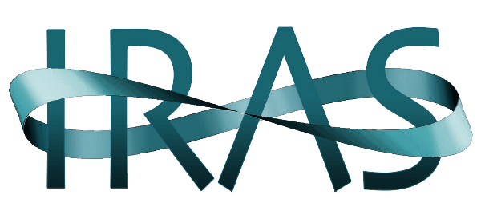
The Institute on Religion in an Age of Science
Founded in 1954

IRAS cultivates a community of informed and respectful inquiry and dialogue
at the intersections of science with religion, spirituality and philosophy
in service of global, societal and personal well-being.

INVITATION TO BECOME A PARTNER OR SPONSOR
OF AN IRAS SUMMER CONFERENCE

We welcome inquiries from organizations that are interested in becoming a Partner or Sponsor of the 2017 Summer Conference (See the Conference Statement following this invitation).

To determine whether you wish to explore this matter, please read the following. Inquiries may be directed to Karl E. Peters, Vice President for Organizational Relations, kpeters396@cox.net.

BECOMING A PARTNER:
​
If you decide to become a Partner of the 2017 IRAS Summer Conference IRAS will:
- Register your members at the IRAS Member/Partner/ Sponsor Rate of $225 – a 30% discount on the normal conference rate of $325.
- Identify and thank you as one of the Conference’s Partners on our website and at the conference.
If you agree, then you will:
- Draw the attention of your members to the 2017 IRAS conference as an event that may be of interest to them and in which you are a Partner. We assume this will be by electronic means and in a manner that fits with your normal way of communicating with your members.
- Point out to your members that they may register for the 2017 conference at the IRAS Member/ Partner/Sponsor Rate of $225 – a 30% discount on the regular $325 rate.
- Later in the Fall we hope to be able to inform you that our Conference Venue, Star Island will offer a 30% discount on room/board to first timers to the island. This discount is $300+. This is now under consideration.

BECOMING A SPONSOR:

If you agree to become a Sponsor, then IRAS will:
- Register any of your members at the IRAS Member/Sponsor/Partner Rate of $225 – a 30% discount from the normal conference rate of $325. (Rates in USA funds.)
- Identify and thank you as one of the Conference’s Sponsors on our website and at the conference
- List your organization as the Sponsor of one of the major presentations of the conference, if you invest $4,000 USD or more.
If you agree, then you will:
- Commit to investing an amount determined by you of $500 USD or more. Note that we have a few major presentations that will be named for those who invest $4,000 USD or more.
- Draw the attention of your members to the 2017 IRAS conference as an event that may be of interest to them and in which you are a Sponsor. We assume this will be by electronic means and in a manner that fits with your normal way of communicating with your members.
- Point out to your members that they may register for the 2017 conference at the IRAS Member/Partner/ Sponsor Rate of $225 – a 30% discount on the regular rate of $325.
- Later in the Fall we hope to be able to inform you that our Conference Venue, Star Island will offer a 30% discount on room/board to first timers to the island. This discount is $300+. This is now under consideration.

Please note that Partners or Sponsors as an organization have no financial obligation for the Conference. Therefore, there is no financial risk to you. The financial risks will be borne by IRAS.

Copyright 2016 by The Institute on Religion on Religion in an Age of Science

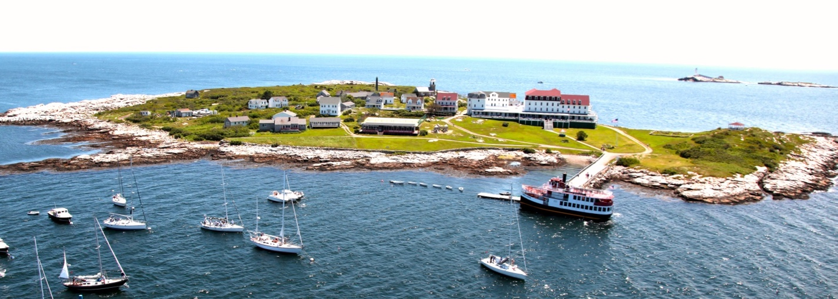

THE “WICKED PROBLEM” OF CLIMATE CHANGE:
WHAT IS IT DOING TO US AND FOR US?
63rd Summer Conference of the Institute on Religion in an Age of Science
In Partnership with the Parliament of the World’s Religions
June 24—July 1, 2017
Star Island off Portsmouth, NH

Climate change is a “wicked problem” with overlapping causes and consequences in economic, ecological, ethical, and technological realms. As climate change continues to alter our planet, how can we use this monumental change as an opportunity for societal and spiritual transformation?

“Uncertainty and ambiguity emerge here as resources, because they force us to confront those things we really want—not safety in some distant and contested future, but justice and self-understanding now.” - Sheila Jananoff

What is the way forward? We must confront climate change as a planetary community. It affects every institution, society, public policy, culture and ecosystem into the foreseeable future. Every possible course of action intertwines with issues of international and intra-societal economic and

Tasks to be addressed:

- Better understand the current scientific expectations for the future of the climate and its impact on our children and on all life.
- Take stock of what we can or can’t control in terms of the consequences of human action.
- Deal with our grief, hope and desires in the midst of great losses and shifts that will occur.
- Recognize the limits and capacities of our evolutionary heritage. Think beyond our current economic and political identities into new ways of imagining and living into the future.
- Move away from anthropocentric thinking and learn to realize our human purposes as part of a finite, planetary community.
- Use the resources of guiding wisdom from the world’s religious and philosophical traditions.
- Formulate compelling narratives of creation care to enable us as persons, groups and cultures to see what needs to be done and have the courage to do it.
- Use new understandings of how we should live to bring about social and economic justice for all in a sustainable earth community.

Coming to terms with what the “wicked problem” of rapid climate change
might do for us will take creativity, imagination, and complex interdisciplinary thinking of organizations like IRAS.

Conference Committee: Emily Austin austin.emily@gmail.com and Karl Peters kpeters396@cox.net, (Co-chairs), Paul Carr (Conference Champion), Tanya Avakian, Jane Bengtson, Marj Davis, Larry Greenfield Sol Katz, Ted Laurenson, Ruben Nelson, Spencer Stober, Emily Troxel, Jennifer Whitten, James van Pelt, and Barbara Whittaker-Johns.

