The “Wicked Problem” of Climate Change:
What is it doing to us, and for us?
Speakers List
Sunday Morning, June 25: Plenary Speaker Panel Introductions
What are we doing to our climate? What is it doing do us?
Afternoon science talk: Paul H. Carr – Conference Champion
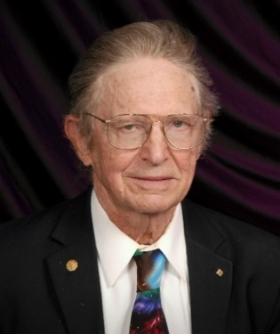 | Paul H. Carr B. S., M. S. MIT; Ph.D. Brandeis U, IEEE Life Fellow, has participated in climate change debates at American Physical Society and IEEE Conferences. He published “Weather Extremes from Anthropogenic Global Warming” in Natural Science (2013). The Templeton Foundation awarded Paul grants for the philosophy course "Science and Religion” he taught at U Mass Lowell, 1998 – 2000. This inspired his book “Beauty in Science and Spirit” (2006). From 1967 to 1995, Paul led a branch of the AF Research Laboratory, which investigated microwave ultrasound and SAW (surface acoustic waves). His over 80 scientific papers and 10 patents have contributed to new components for radar, TV, and cell phones. His home page is www.MirrorOfNature.org
What are we doing to our climate? Since the beginning of the industrial age, emissions from fossil fuel burning have raised carbon dioxide concentrations to 400 ppm. This is 33% higher than in the last million years. This increase is warming our planet via the Greenhouse Effect. At the present rate of carbon dioxide increase, we will reach 800 ppm by 2100. When our earth was at this concentration 40 million years ago, it was so warm that there was no ice. Sea levels were about 300 feet higher than today.
What is climate change doing to us? Dry regions are drier and wet ones wetter. Wildfires are growing, storms more violent, floods setting record heights, glaciers melting and seas rising. Parts of Earth are increasingly uninhabitable, resulting in millions of climate change refugees.

Can World Food Production Keep up with Population Growth in the Face of Climate Change?
Monday morning dialogue partners:
Solomon Katz and Barry Costa - Pierce
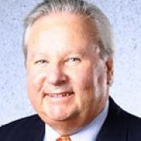 | Solomon H. Katz, Ph.D is a leading expert on the anthropology of food. He was editor-in-chief of the Encyclopedia of Food and Culture published by Scribner (2003). Prof Katz was Chair of the AAA Task Force on World Food Problems 2007 – 2015. He is director of the Krogman Center for Childhood Growth and Development at the University of Pennsylvania. His work in the field of science and religion spans 30 years with leadership in the Institute for Religion in Age of Science (IRAS), in which he served as president from 1981 to 1984, and as associate editor of Zygon: Journal of Religion and Science. A member of the PCRS board, Katz also serves on the board of the American Association for the Advancement of Science (AAAS) and serves on several committees including the Dialogue Between Science and Religion.
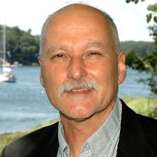 | Barry Costa-Pierce, Ph.D is the Henry L. & Grace Doherty Professor of Marine Sciences, Chair of the Department of Marine Sciences and Director of the Center for Excellence in the Marine Sciences at the University of New England in Biddeford, Maine. He has a Ph.D. in Oceanography from the University of Hawaii and an M.Sc. from the University of Vermont. His research interests are in “ocean food ecosystems”: how seafood systems throughout the world interact with marine ecosystems, fisheries, aquaculture, and people. He has lived and worked as a scientist in Asia, Africa, and the Pacific. He is widely recognized as a pioneer of the field of “Ecological Aquaculture” and helped develop the UN Food and Agriculture Organization’s global protocols for an “Ecosystems Approach to Aquaculture.” In 2011, he was elected as a Fellow of the American Association for the Advancement of Science.
Ocean Climate Change
Afternoon Scientist: Robert S. Pickart
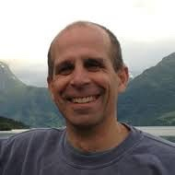 | Robert S. Pickart, Ph.D. in physical oceanography from MIT and the Woods Hole Oceanographic Institution (WHOI), is a Senior Scientist at WHOI. His research focuses on high latitude processes, including air-sea interaction and the exchange of water between the shelves and the deep ocean. He does fieldwork in both the Atlantic and Pacific sectors of the Arctic Ocean, and has recently been investigating ecosystem impacts of climate change. Bob is the author or co-author of 120 refereed scientific publications. His cruises often provide online education for grade school students and the lay public (see http://arcticspring.org/). He recently received the Henry Stommel Research Award from the American Meteorological Society for his pioneering work at high latitudes.

Maintaining Hope, Acting for Justice
Tuesday morning dialogue partners:
Carol Wayne White and Barbara Rossing
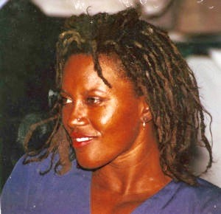 | Carol Wayne White, Ph.D. is Professor of Philosophy of Religion at Bucknell University, where she teaches courses in philosophy of religion and religious naturalism. Her latest book is Black Lives and Sacred Humanity: Toward an African-American Religious Naturalism (Fordham U. Press, 2016). In it White constructs a concept of sacred humanity grounded in the writings of Anna Julia Cooper, W. E. B. Du Bois, and James Baldwin. Supported by current theories in science studies, critical theory, and religious naturalism, this concept offers a capacious view of humans as interconnected, social, value-laden organisms with the capacity to transform themselves and create nobler worlds wherein all sentient creatures flourish.
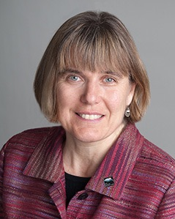 | Barbara R. Rossing Th.D. Harvard Divinity School, is professor of New Testament at the Lutheran School of Theology at Chicago, is involved in environmental initiatives at the seminary, and is a board member of the Center for Advanced Study in Religion and Science (CASIRAS). She served as pastor of a congregation in Minnesota, director for Global Mission Interpretation for the American Lutheran Church, pastor at Holden Village Retreat Center, Chelan, Wash., and chaplain at Harvard University Divinity School.  Rossing has lectured and preached widely, including events for the Evangelical Lutheran Church in America (ELCA), as well as ecumenical theological conferences. As a public theologian her media appearances have included “CBS Sixty Minutes” as well as The History Channel, National Geographic, Living the Questions, and numerous print and radio interviews.  Her publications include The Rapture Exposed: The Message of Hope in the Book of Revelation (Basic Books, 2004); The Choice Between Two Cities: Whore, Bride and Empire in the Apocalypse (Trinity Press, 1999); and articles and book chapters on the Apocalypse and ecology.
Terrestrial Carbon Transformations
Afternoon scientist: Emily E. Austin
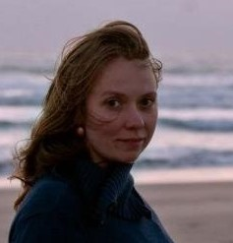 | Emily E. Austin, Ph. D. is an ecosystem ecologist and a soil biogeochemist at the University of New Hampshire. Her research focuses on the interactions between abiotic and biotic components of natural and managed ecosystems especially in a context of global change. Her projects address the response of soil microbial communities to multiple climate drivers and elevated CO2, the response of carbon cycling to experimental warming, and mechanisms for soil carbon storage in association with the use of cover crops in a bioenergy system. Emilyeaustin.com
Changing course: How social brain empathy and politically viable technology can impact climate change.
Wednesday morning dialogue partners:
Bill Shoemaker and Jim Rubens
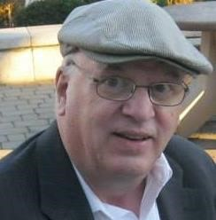 | Bill Shoemaker, Ph.D. is a neuroscientist who received his Ph.D. from the Massachusetts Institute of Technology (MIT) and has held positions at the National Institute of Mental Health, the Salk Institute in La Jolla, CA, and currently at the University of Connecticut Health Center in Farmington, CT. He is on the Psychiatry faculty, where he teaches residents and medical students, and in the Neuroscience Graduate Program. He has authored more than 100 scientific research publications. Recently, Dr. Shoemaker has been writing concerning the interface between neuroscience and religion.
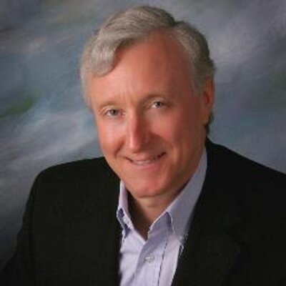 | Jim Rubens dropped out of Dartmouth College to join a commune and start a recycling center, then dropped back in to grow and sell about 10 businesses. He chaired the platform committee for the US Independent party in 1992, served as a state senator in NH, ran for governor, chaired the New Hampshire State GOP platform committee, and ran in the primary for Republican US Senate in 2016. He authored the book OverSuccess: Healing the American Obsession With Wealth, Fame, Power, and Perfection in 2008.  Rubens stands out in the Republican Party as openly acknowledging the existence of climate change and working to support green energy startups. Today Rubens is an angel investor to New England startups and consults for the Union of Concerned Scientists on clean energy and politics.

Creation Spirituality: Pope Francis
“On Care for our Common Home”
Thursday morning dialogue partners:
Matthew Fox & Ellen Kennedy
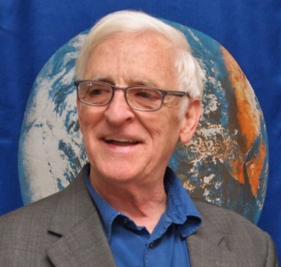 | Matthew Fox, Ph.D. holds a doctorate in spirituality from the Institut Catholique de Paris and has authored 32 books on spirituality and contemporary culture that have been translated into 60 languages. Fox has devoted 45 years to developing and teaching the tradition of Creation Spirituality and in doing so has reinvented forms of education and worship. His work is inclusive of today’s science and world spiritual traditions and has awakened millions to the much neglected earth-based mystical tradition of the West. His student wrote a large portion of Pope Francis’ Laudato Si, On Care for our Common Home. Among Fox’s books are: A Way to God: Thomas Merton’s Creation Spirituality Journey, An Original Blessing, The Coming of the Cosmic Christ, and Meister Eckhart: A Mystic-Warrior for Our Times.
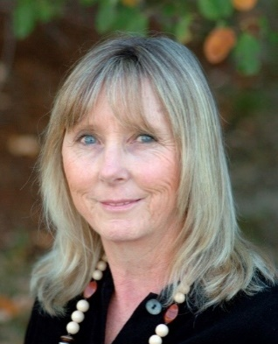 | Ellen Kennedy will be joining Matthew Fox weaving the threads of creative experience into the fabric of our gathering through the gift of Sacred Circle Dance (SCD). Each simple dance is taught. Ellen was trained and certified at The Findhorn Foundation in Scotland and teaches Sacred Circle Dance in the US and internationally. She is known for her ability to incorporate Sacred Circle Dance as a centering and grounding force building community in group dynamics at retreats and conferences. “Sacred Circle Dance is a delightful way to access free energy” Briane Swimme, cosmologist, “Ellen, queen of the dance – what beauty, love and guidance you bring through us all.” Joan Borysenko, PHD. scientist

Friday: Closing Panel and Science Communication.
Speaker Panel will review the conference and discuss how to communicate climate change beyond our Star Island Conference.

Morning Chapel Services:
Conference Chaplain: Rev. Dr. Mary Westfall
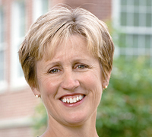
Chaplain Rev. Dr. Mary E. Westfall has been Senior Minister at Community Church, UCC, Durham, NH, since 1999. Her commitment to the environment, along with her interest in the emerging dialogue between religion and science, led her to pursue her Ph.D. at the University of New Hampshire Natural Resources Program. Mary was the Executive Director of the United Campus Ministry and Chaplain to University of New Hampshire for 11 years. She was Associate Pastor at West Park Presbyterian Church in New York City.

